

**BENHA UNIVERSITY**

**BENHA FACULTY OF ENGINEERING**

**DEPARTMENT OF ELECTRICAL ENGINEERING**

**Ultimate Guide for Design of VFD**

**Prepared By:**

Ahmed Mohsen Abouelyazed

Section 1 - Power & Control Engineering

**Subject**Power Electronics (B)

**Supervised by:**Dr. Mohammed Awaad

**Semester:**

3rd Year – 2st Semester

Department of Electrical Engineering,  
Benha Faculty of Engineering, Benha University

%3CmxGraphModel%3E%3Croot%3E%3CmxCell%20id%3D%220%22%2F%3E%3CmxCell%20id%3D%221%22%20parent%3D%220%22%2F%3E%3CmxCell%20id%3D%222%22%20value%3D%22%22%20style%3D%22pointerEvents%3D1%3BverticalLabelPosition%3Dbottom%3Bshadow%3D0%3Bdashed%3D0%3Balign%3Dcenter%3Bhtml%3D1%3BverticalAlign%3Dtop%3Bshape%3Dmxgraph.electrical.signal_sources.protective_earth%3B%22%20vertex%3D%221%22%20parent%3D%221%22%3E%3CmxGeometry%20x%3D%22292%22%20y%3D%22608%22%20width%3D%2225%22%20height%3D%2220%22%20as%3D%22geometry%22%2F%3E%3C%2FmxCell%3E%3C%2Froot%3E%3C%2FmxGraphModel%3E

* 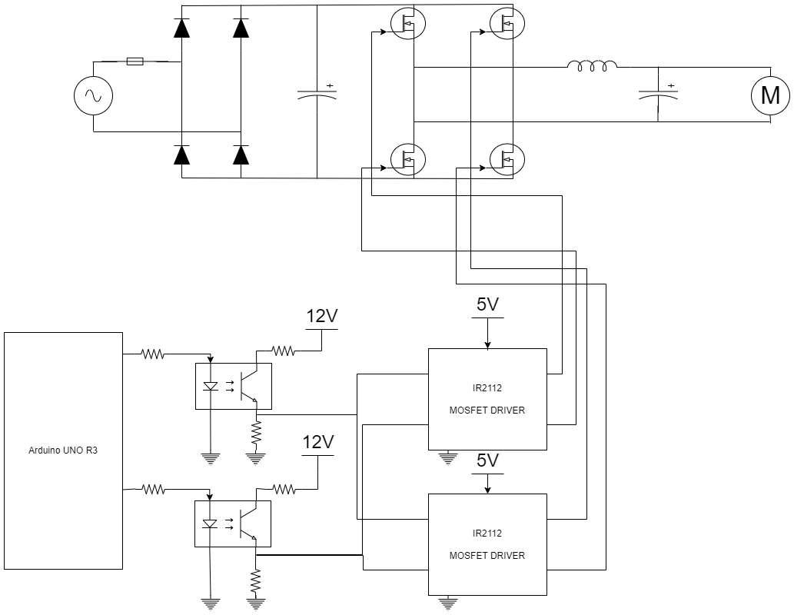 GENERAL DIAGRAM OF SINGLE-PHASE VFD:
* 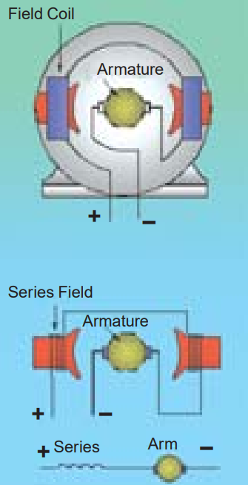 Data about load (From nameplate and datasheet):
* Type: Evaporator Fan Motor - Universal motor
* Manufacturer: ELCO
* Model: NET2C16PVN002
* Voltage: 230/240 VAC
* 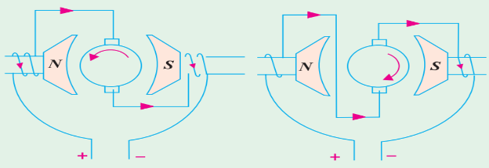Frequency: 50/60Hz
* Power: Maximum output: 16W , Continuous input: 65W
* Current: 0.45A (at full load)
* Speed: 1300 RPM (50Hz) / 1550 RPM (60Hz)
* Service Class: CL/B (Refers to a continuous duty motor with sleeve bearings)
* Operating Temperature Range: -30° to +40°C
* Additional Analysis and Calculations for Motor Parameters:
* 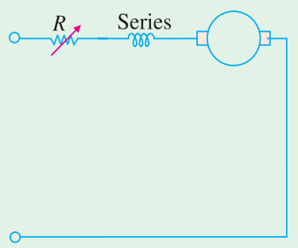Input Apparent power: $S_{in}=V_{T}I_{a}=230×0.45=103.5 VA$
* Input Power Factor:

+ Eb,ac -

+

VT

_

Ra

Xa

* Total Impedance: $Z_{in}= \frac{V_{T}}{I_{a}}=\frac{230}{0.45}=511.11 Ω$

Ia

* 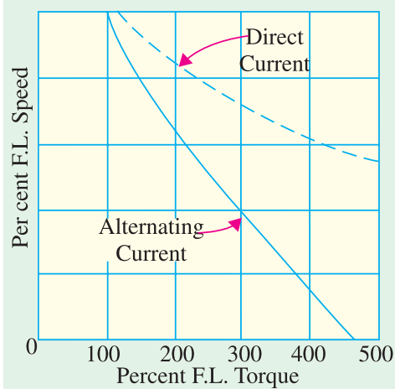Reactive power: $Q_{in}=\sqrt{{S_{in}}^{2}-{P_{in}}^{2}}=\sqrt{{103.5}^{2}-{65}^{2}}=80.54 VAR$
* Motor Reactance: $X_{a}=\frac{Q_{in}}{{I_{a}}^{2}}=\frac{80.54}{{0.45}^{2}}=397.728 Ω$
* Motor Inductance: $L_{a}=\frac{X_{a}}{2πf}=\frac{397.728}{2π×50}=1.266 H$
* Motor Resistance: $R_{a}=\sqrt{{Z_{in}}^{2}-{X_{a}}^{2}}=\sqrt{{511.11}^{2}-{397.728}^{2}}=321 Ω$
* induced Voltage: $E_{b,ac}=-I_{a}R_{a}+\sqrt{{V_{T}}^{2}-{\left(I_{a}X_{a}\right)}^{2}}=0???$
* Developed Torque: $T_{D}= \frac{P_{mech}}{ω_{r}}=\frac{E_{b,ac}I_{a}}{2πn_{r}}×60=0???$
* Source: 220V AC , 50 Hz , THDi & THDv are discussed later.
* Rectifier: Analysis of Bridge Rectifier pre- and post-adding smoothing capacitor.
* Pre-adding smoothing capacitor:
$V_{m}=\sqrt{2}V_{rms}=\sqrt{2}×220=311.127 V$

$V_{dc}=\frac{2V_{m}}{π}=\frac{2×311.127}{π}=198.0696 V$

$r=\sqrt{{(\frac{V_{rms}}{V_{dc}})}^{2}-1}=\sqrt{{(\frac{220}{198.0696})}^{2}-1}×100\%=48.3426\%$

* Post-adding smoothing capacitor:
$V_{m}=\sqrt{2}V_{rms}=\sqrt{2}×220=311.127 V$

$assume: V_{rpp}=10\% of V_{rms}=22 V$

$V_{r,rms}=\frac{V_{rpp}}{2\sqrt{3}}=\frac{22}{2\sqrt{3}}=6.35085 V$

$V_{dc}=V_{m}-\frac{V_{rpp}}{2}=311.127-\frac{22}{2}=300.127 V$

$r=\frac{V_{r,rms}}{V_{dc}}= \frac{6.35085}{300.127}×100\%=2.11605 \%$

$assume:R_{L}=1KΩ→ ∴C≈ \frac{1}{4\sqrt{3}fR_{L}r}=\frac{1}{4\sqrt{3}\left(50\right)\left(1000\right)\left(\frac{2.11605}{100}\right)}=136.422 μF → C_{design}=1.25 C=170.53 μF$

* For Quick Calculation use: $C=\frac{1}{4\sqrt{3}fR_{L}\left(\frac{\frac{V_{rpp}}{2\sqrt{3}}}{V_{m}-\frac{V_{rpp}}{2}}\right)}$
* Single-Phase Inverter:
* Assumptions: Full H-Bridge , N-MOSFET , Modulation Technique used: Bipolar SPWM, $V_{dc}=300 V$
* Assumptions for design: $V_{o,1}=210 Vrms , f=50 Hz , R_{L}=321 Ω , L=1.266 H , {THD}_{i}=1\%$
* Design:
$m_{a}= \frac{V_{1,max}}{V_{dc}}=\frac{210×\sqrt{2}}{300}=0.99$

$I_{1}=\frac{V_{1}}{Z_{1}}=\frac{210×\sqrt{2}}{\sqrt{{321}^{2}+{(2π×50×1.266)}^{2}}}=0.581 A$

${THD}_{i}=0.01=\frac{\sqrt{\sum_{n=2}^{∞}{{(I_{n,rms})}^{2}}}}{I_{1,rms}} → ∴\sqrt{\sum_{n=2}^{∞}{{(I_{n,rms})}^{2}}}=0.01I_{1,rms}=0.01×\left(\frac{0.581 A}{\sqrt{2}}\right)=4.11 mA$

$I_{mf}=0.01I_{1}=0.01×0.581=5.81 mA$

* Table 8-3 indicates that the normalized voltage harmonic for n = mf and for ma = 1 is 0.6. The voltage amplitude for n = mf is then:

$V_{mf}=0.6V_{dc}=0.6×300=180 V$

$Z_{mf}=\frac{V_{mf}}{I_{mf}}=\frac{180}{5.81 ×{10}^{-3}}=30981.06713 Ω → ∵ Z_{mf}≫R_{L} → ∴ Z_{mf}≈ ωL=m_{f}ω_{0}L$

$m_{f}ω_{0}L> Z_{1}=511.1 Ω → ∴ m_{f}>\frac{Z_{1}}{ω_{0}L}=\frac{511.1}{2π×50×1.266}=1.28 →Let m_{f}=3$

$f_{tri}=m_{f}f_{sine}=3 ×50=150 Hz$